

**Dhaka University of Engineering & Technology, Gazipur**

Department of Computer Science and Engineering

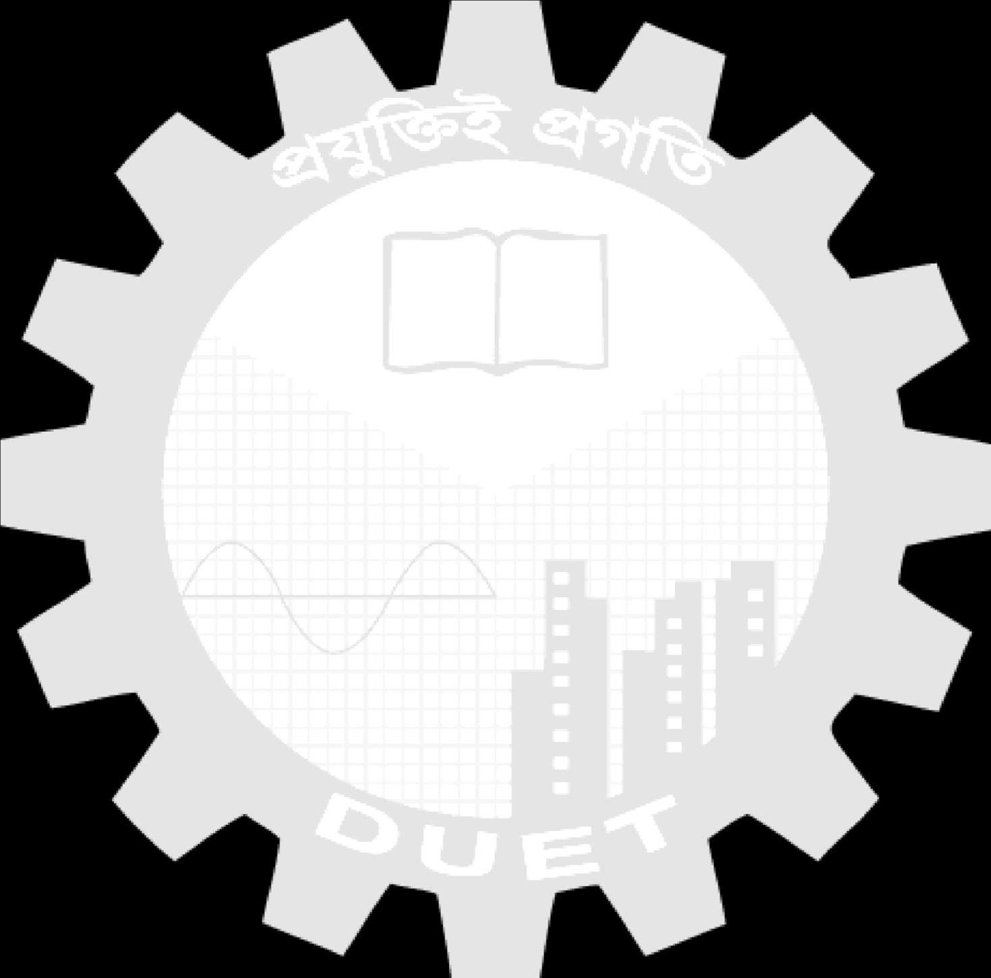

Course Code: CSE 3812

Course Title: Microprocessor and Interfacing Sessional

|  |  |
| --- | --- |
| Date of Experiment: | 06/10/24 |
| Date of Submission: |  |

# Report No: 01

**Name of the Report: Program Structure and Arithmetic Operations using**

**Assembly Language Program in EMU8086**

**Submitted To**

**Dr. Mohammad Abdur Rouf**

PROFESSOR

Department of CSE

DUET, Gazipur

**Md. Rajibul Islam**

LECTURER

Department of CSE

DUET, Gazipur



**Submitted By**

Name: Golam Mostafa Rabby

Student ID: 214036

Year/Semester: 3rdYear/1stSemester

Section: A

Signature of Teacher